• William Hsu10/7 3:12 PM
Open IE meeting - Tue 07 Oct 2025
• OIE Task Page: https://kstate.atlassian.net/wiki/x/AYDL7Q
Log in with Atlassian account
Log in to Jira, Confluence, and all other Atlassian Cloud products here. Not an Atlassian user? Sign up for free.
kstate.atlassian.net
• Open IE Nav Bar
- [NL] Chat | Channel | Team | Wiki
- [OIE] Chat | Channel | Plan | Lit | Dev | Wiki
Log in with Atlassian account
Log in to Jira, Confluence, and all other Atlassian Cloud products here. Not an Atlassian user? Sign up for free.
kstate.atlassian.net
• William Hsu10/7 3:29 PM
General | KDD Lab Natural Language (NL) Division | Microsoft Teams
Join conversationteams.microsoft.com
• This message has been deleted.
• Mobina Golmohammadi10/7 3:40 PM
Just LT!
• Jahid Chowdhury Choton10/7 3:51 PM
I'm interested
1 White question mark reaction.
• sure
• William Hsu10/7 4:03 PM
[NL] Open IE meetings: https://kstate.atlassian.net/wiki/x/GgCH6w
• Captioning v2t SOTA: GiT Pali BLIP-2

Google AI Overview
GiT Pali BLIP-2 appears to be a misinterpretation or combination of different vision-language models. Here's a breakdown of the relevant terms:
- BLIP-2: This is a well-known vision-language model developed by Salesforce. It focuses on efficiently bridging the gap between frozen pre-trained image encoders and large language models (LLMs) using a lightweight Querying Transformer (Q-Former). BLIP-2 achieves state-of-the-art performance on various vision-language tasks like image captioning and visual question answering, while being significantly more compute-efficient than previous models like Flamingo.
- PaliGemma: This is a family of vision-language models developed by Google, built upon the Gemma architecture. PaliGemma models are designed for a wide range of visual-language understanding tasks, including fine-tuning for specific applications like text rendering and capturing spatial relations in captions.
- GiT (Generative Image-to-Text): This is a general term referring to models that generate text descriptions from images. While BLIP-2 and PaliGemma are examples of GiT models, "GiT" itself is not a specific model name in this context.
In summary, there is no single model called "GiT Pali BLIP-2." It seems to combine elements from:
- BLIP-2: A prominent model for efficient vision-language pre-training.
- PaliGemma: Google's family of vision-language models.
- GiT: A general category of models that generate text from images.
It is possible the user is interested in a model that combines aspects of BLIP-2's efficiency or methodology with the capabilities of PaliGemma, or simply exploring various approaches to generative image-to-text tasks.

AI responses may include mistakes.

• NIST TAC Tracks
https://tac.nist.gov//tracks/index.html
• William Hsu10/7 4:11 PMWilliam Hsu10/7/2025 4:05 PMNIST TAC Tracks https://tac.nist.gov//tracks/index.html
Linked under 2. Technical Background and Training of [NL] Open IE page
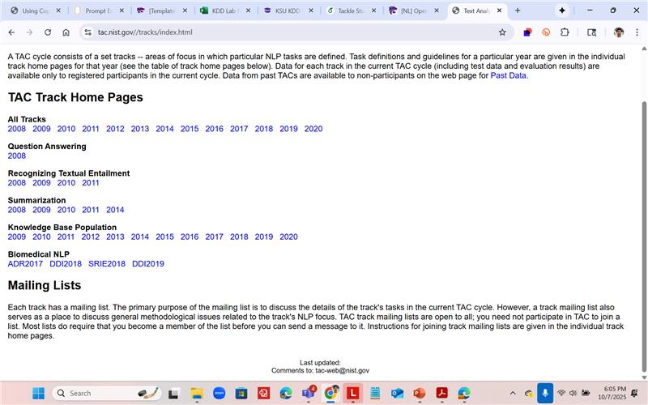

• William Hsu10/7 4:19 PMEditedWilliam Hsu10/7/2025 4:11 PMLinked under 2. Technical Background and Training of [NL] Open IE page 📷
Past IE notes (2009):
- http://kdd.cs.ksu.edu/KSU/CIS/KSU-CIS-20090930.pdf
- https://kdd.cs.ksu.edu/KSU/CIS/KSU-CIS-20090930.pptx
- https://kdd.cs.ksu.edu/KSU/CIS/KSU-CIS-20090930.avi
- https://kdd.cs.ksu.edu/KSU/CIS/KSU-CIS-20090930.mp4
• New KDD Library: 08-Library
• JIA Shuyue (Guest)10/7 4:22 PM
I have to go, William!
• William Hsu10/7 4:23 PM
K-State KDD Lab SharePoint: General
• William Hsu10/7/2025 4:23 PMK-State KDD Lab SharePoint: General
KDD Colloquium, c. 2017-2022: Videos
• EditedWilliam Hsu10/7/2025 4:25 PMKDD Colloquium, c. 2017-2022: Videos
Past colloquia: https://www.kddresearch.org/page/colloquium-past
• William Hsu10/7/2025 4:27 PMPast colloquia: https://www.kddresearch.org/page/colloquium-past
Next time
- Seed list for Open IE domain - neuroscience & mental health
- QG spec for Task, 1, 2, 7 - see Deep learning with constraints for answer-agnostic question generation in legal text understanding (2021) by Deepti Lamba
- Infrastructure for crawler - cobalt.tools, QG primpts, ranking prompts
- HITL crawl spec for DC on YT & Reddit - current way of getting seeds for Task 1
- IE baselines - benchmark tasks
• William Hsu10/7/2025 4:31 PMNext time Seed list for Open IE domain - neuroscience & mental healthQG spec for Task, 1, 2, 7 - see Deep learning with constraints for answer-agnostic question generation in legal text understanding (2021) by Deepti LambaInfrastructure for crawler - cobalt.tools, QG primpts, ranking prompts
Meanwhile: get on Open IE GitHub Project
• EditedWilliam Hsu10/7/2025 4:33 PMMeanwhile: get on Open IE GitHub Project
Subdirs for task under Open IE code repository on GitHub
• Patrick Stingley10/7 4:34 PM
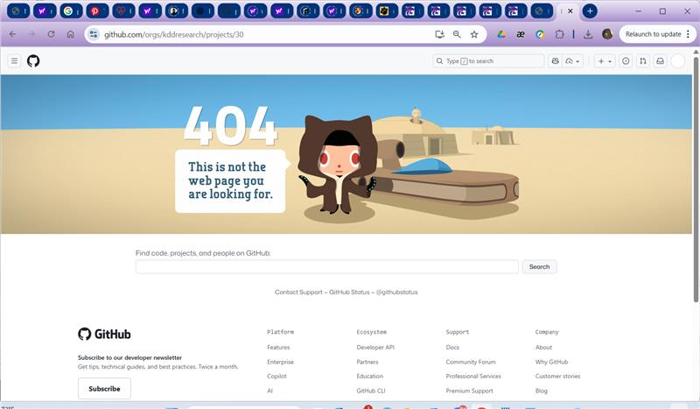
• I can't get into the github
• William Hsu10/7 4:39 PMPatrick Stingley10/7/2025 4:34 PM📷
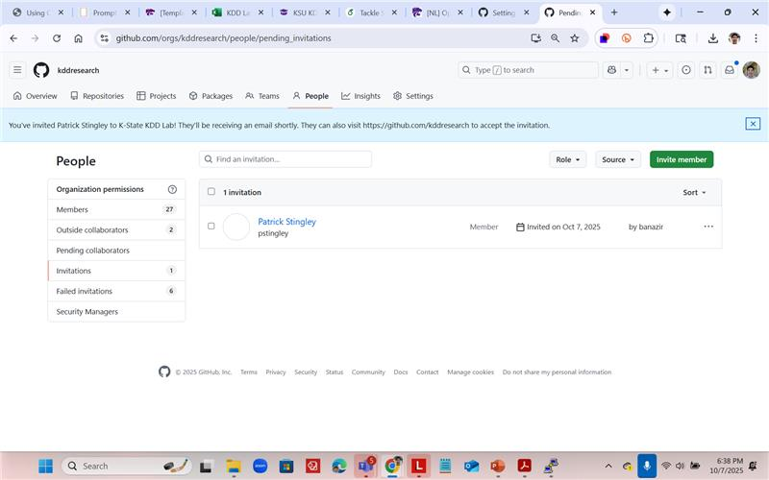
• EditedWilliam Hsu10/7/2025 4:39 PM📷
Promoted Chipo & Jahid to admins
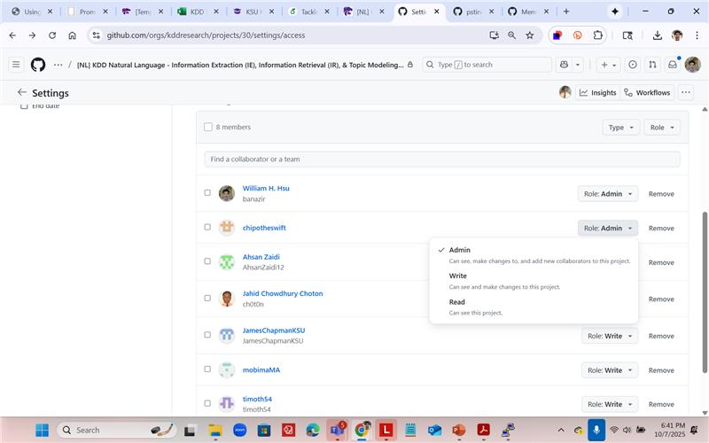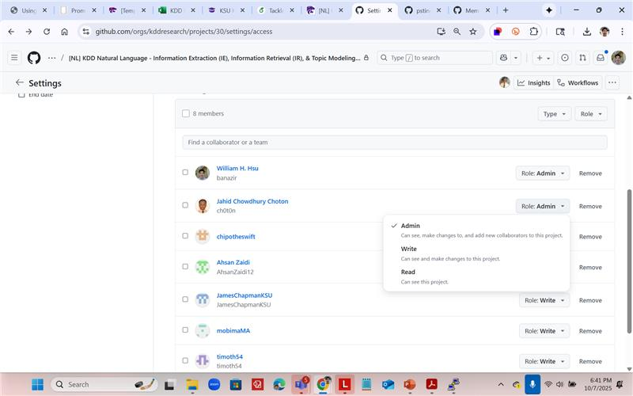
• Jahid Chowdhury Choton10/7 4:42 PM
Have to go. will follow up
1 Like reaction with medium light skin tone.
• William Hsu10/7 4:46 PMEditedWilliam Hsu10/7/2025 4:42 PMPromoted Chipo & Jahid to admins 📷 📷
Already in:
- Mobina Golmohammadi
- James Chapman
- Yihong Theis
- Timothy Tucker
- Jahid Chowdhury Choton
- Syed Ahsan Masud Zaidi
Invited:
- Patrick Stingley
- Chipo Sekabanja - admin
To invite:
- Manny Adeniji
- Shuyue Jia (Bruce Jia)
- David Kurtenbach
To check:
- Joshua Garcia
• Patrick Stingley10/7 4:54 PM
I'm in GitHub
1 Like reaction with medium light skin tone.
• William Hsu10/7 4:54 PMWilliam Hsu10/7/2025 4:46 PMAlready in: Mobina GolmohammadiJames ChapmanYihong TheisTimothy TuckerJahid Chowdhury ChotonSyed Ahsan Masud Zaidi Invited: Patrick StingleyChipo Sekabanja - admin To invite: Manny AdenijiShuyue Jia (Bruce Jia)David Kurtenbach To check: 🪪Joshua Garcia
Please paste William Hsu: GitHub IDs needed | K-State KDD Lab > KDD members | Microsoft Teams
• Recording has stopped. Saving recording…10/7 4:59 PM Recording has stopped. Saving recording…

